**DEPARTMENT OF INFORMATION TECHNOLOGY**

**PSG COLLEGE OF TECHNOLOGY**

**COIMBATORE-641004**



**JUNE-2020**

**RESPONSIVE WEB DESIGN**

**TITLE: PEOPLE WELFARE ANDCOMPLIANT REGISTRATION SYSTEM**

**BATCH DETAILS:**

1. **Juhishree V (18i320)**
2. **Keshini P.S (18i326)**
3. **Pasumarthi Gopal Rakshith (18i334)**
4. **Prathikksha S.M (18i336)**
5. **Sujaybharath P (18i356)**

**About The Project:**

‘People Welfare Enhancement And Compliant Registration System’ would be an ideal model for anyone who wants to establish their thoughts to work for the welfare of the common people. We came forward with different goals, consistent rules and group of benefits. When it comes to roadway and electrical issues, safety is paramount. Some of the critical problems related to issues in the roadways and electricity line are being resolved and trouble shooted by National roadways and electricity department, but not all the queries from the society are met and resolved. It has been a tedious work for the people to leave the complaints in the department branches located at particular places in each state.

People usually write complaints and bring their issues to the notice of the department. Repeated complaints in writing are being made and follow-ups are done with the department engineers. Most of the rural areas don’t have supporting offices to meet these troubles. Holding on to these kind of issues, we came forward to create a webpage that aids in developing the public welfare of people. This webpage would enhance people to bring their queries to the notice of department effortlessly.

People can login and add some information about their locality and issues. Users who post their queries through online would be notified after submission when admin perceives the conditions. This becomes the easiest way to bring the public welfare problems to light and to settle all the problems concerning public issues. This work gives us an opportunity to explore a variety of approaches to matters of central importance to an understanding of Indian working teams for settling problems and our society.

This would serve as a big tracing medium to recognize and clear up the rural and urban people’s need to elucidate their common troubles. The system is implemented using a 3-tier approach, with a backend MySQL database, a middle tier apache server and a web browser as the front end client. In order to develop online shopping application use HTML, CSS, JAVA Script, server side scripting language PHP and relational database MySQL.

**Instructions For Running The Project:**

**Respected sir,**

1. In the Xampp and turn on **apache and my sql** .
2. Put the entire folder named **PeoplewelfareEnhancementSystem** inside the **Htdocs** folder of your xampp directory.
3. Open chrome and and type in search box <http://localhost/dashboard/>
4. Click on **PhpMyadmin**
5. Create two databases namely **itc and welfare.**
6. Open **itc** database and select **import** option and import the file named **registration.sql**
7. Similarly open **welfare** database and select **import** option and import the file named **welfare.sql**
8. Now all the tables required for our project will be created.
9. The table **registration** will be created under itc database and the tables **details,login,login1**  will be created under the welfare database.
10. The homepage of our webpage is **main.html.** To open the page ,open a new tab in **chrome** and in the search box type <http://localhost/peoplewelfareEnhancementSystem/main.html>.

**10)**The main page will be displayed.

**Result And Output Screenshots:**

Let us see the overview of our project.

This is the front page which serves as entry to both user ad admin.

**Admin**: clicking on the admin takes you to registered complaint section.

**User:** This redirects you to login page

**New user:** Allows user to create a account

**Help:** Provides information regarding this page.

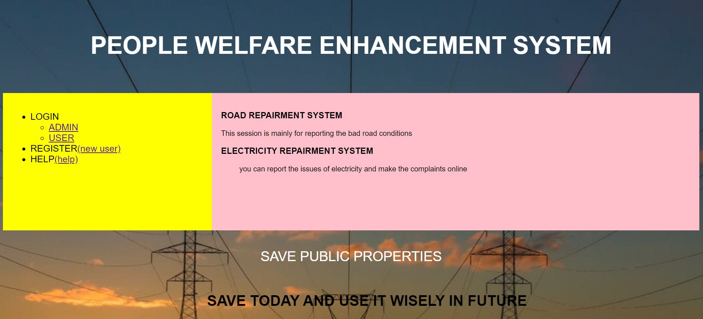

Let us register a complaint regarding electricity issue. First he/she has to to create account. For that click on  **new user** in the front page. clicking on that page takes you to account creation page.

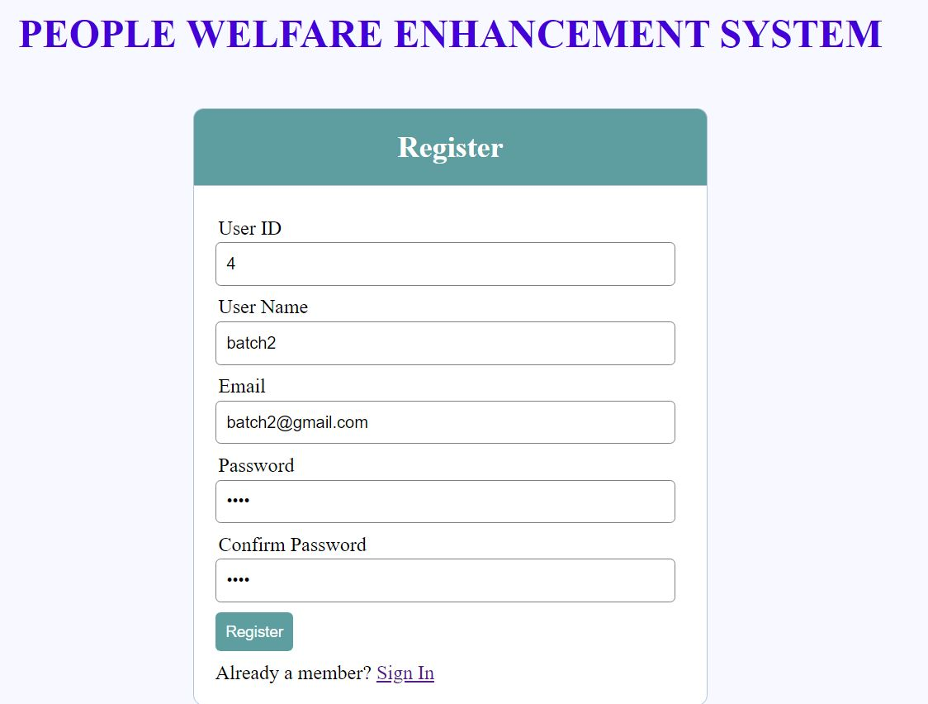

on clicking register the data will be stored in table **Database table which is created using xampp named ‘registration’ under ‘itc’ database.**

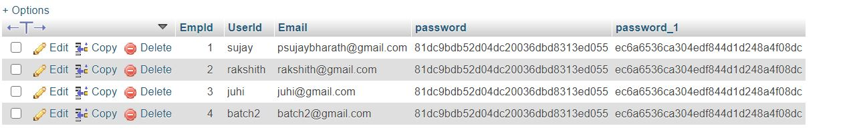

The data entered in form has been updated in the table.

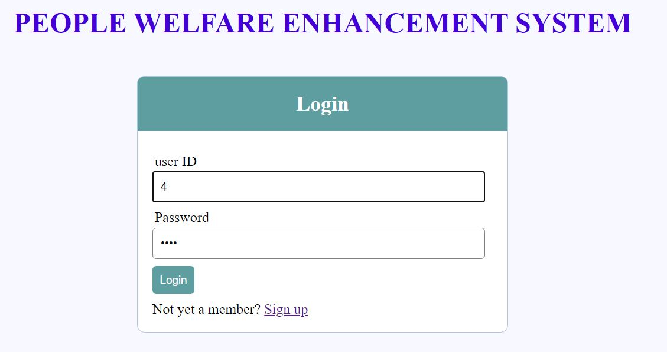

Enter the user id and password and click **login.** This will take you to complaint registration page.

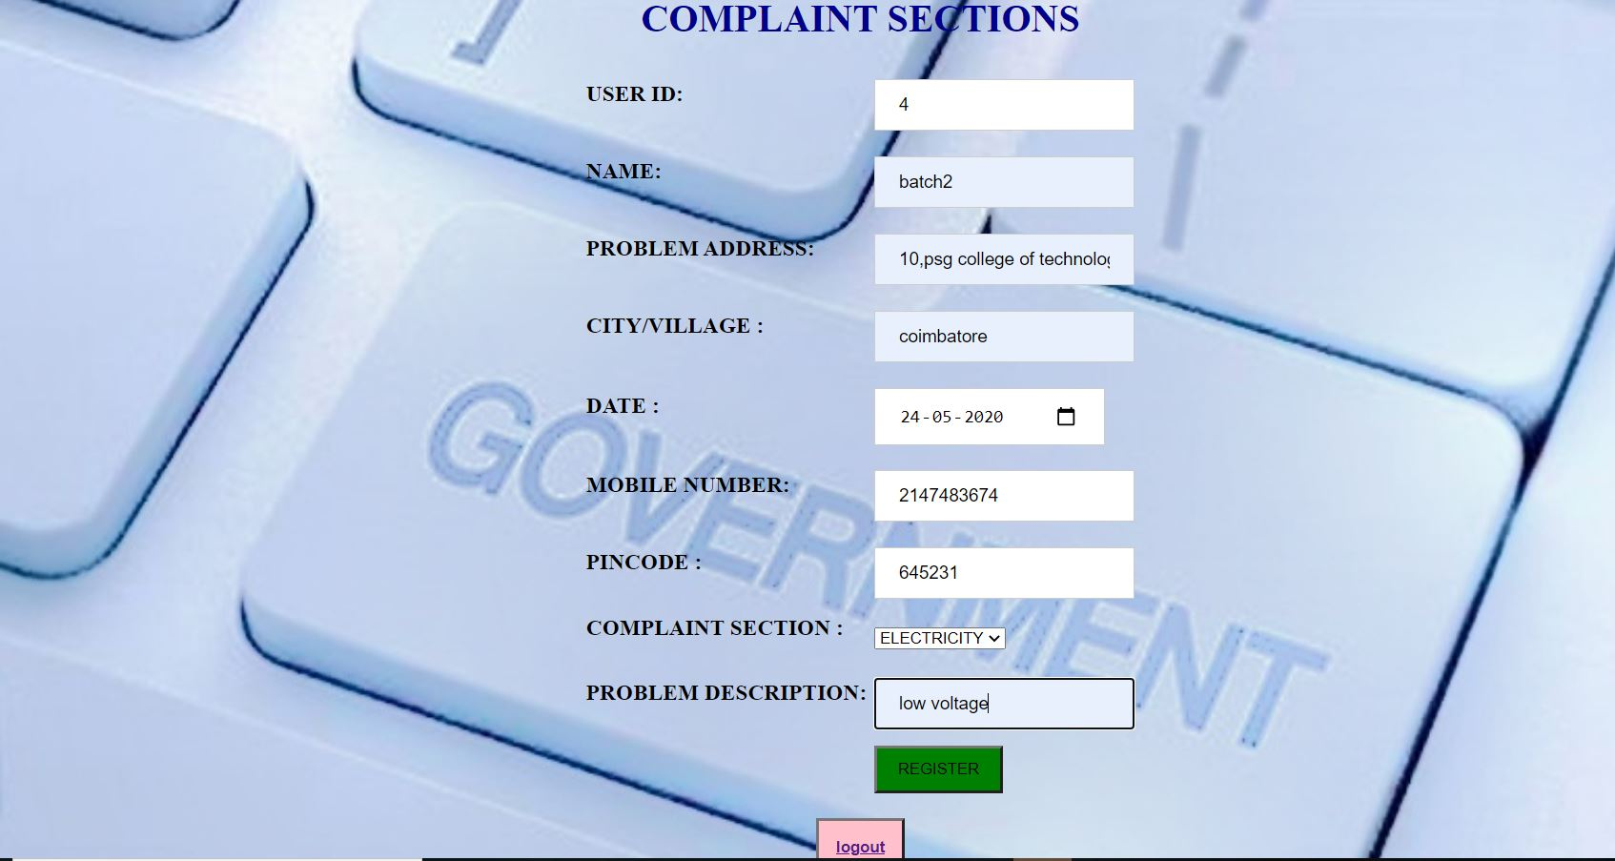

After filling the complaint details, click on register. The complaint details will be stored in the table name0d

+ **details**.

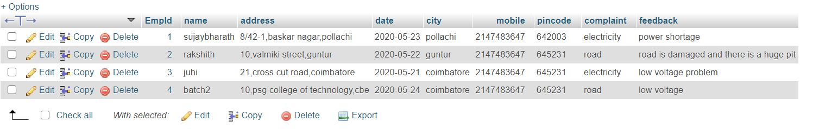

Then Admins can view the complaints by clicking **admin** in the front page which is shown first. Clicking on the **Admin** takes you to this page.

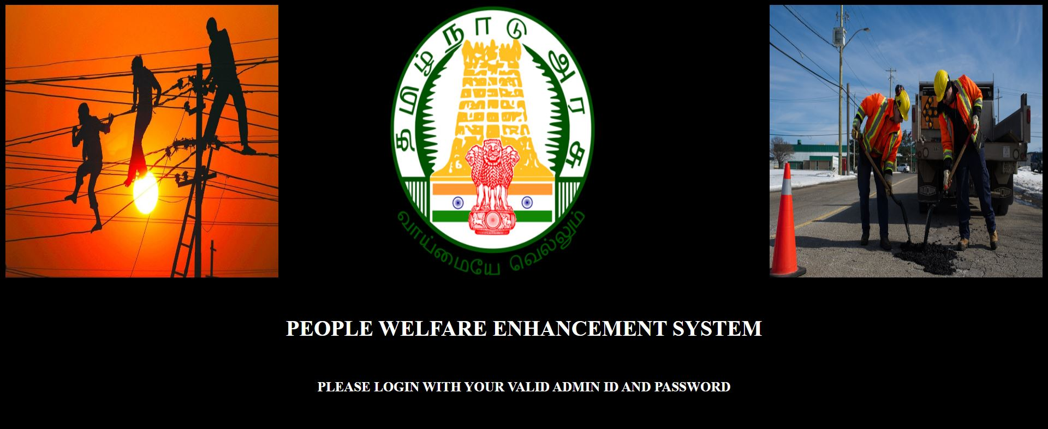

Now there are two images on left and right side.

Clicking on the left side image takes you to **Electricity admin’s login.**

Clicking on the left side image takes you to **Road admin’s login.**

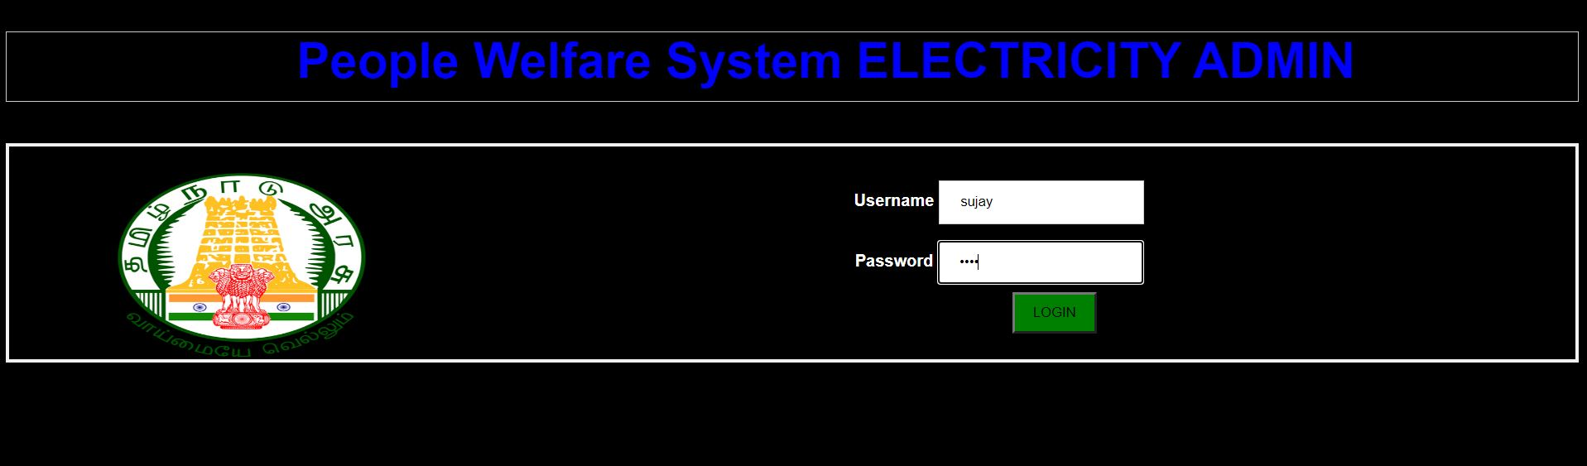

After entering admin name and password it will show the complaints registered as shown below in the tabular format.

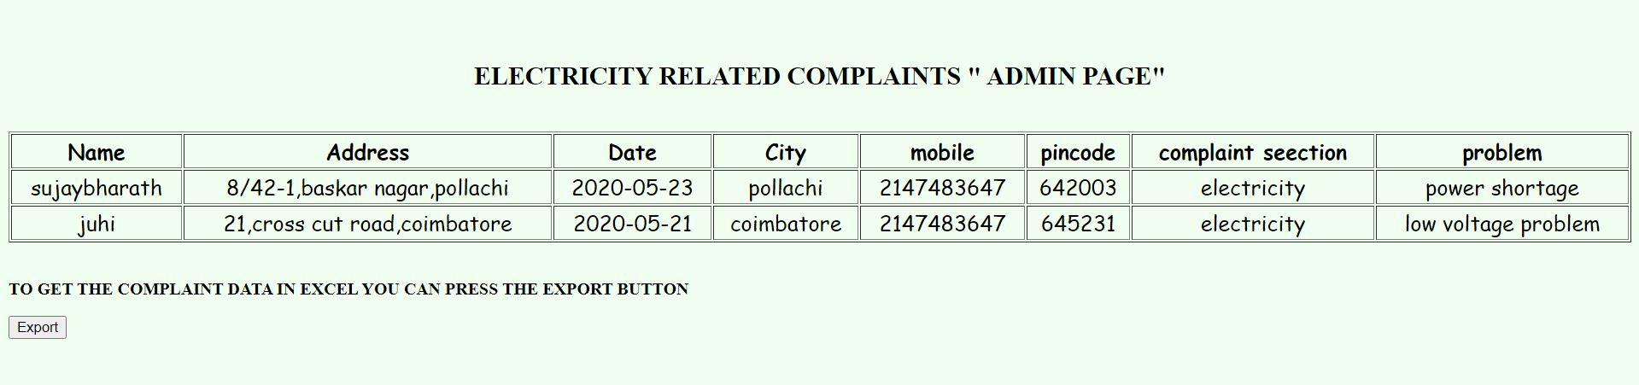

This same procedure can be implemented for **Road admin’s login** page too by entering admin’s id and password.

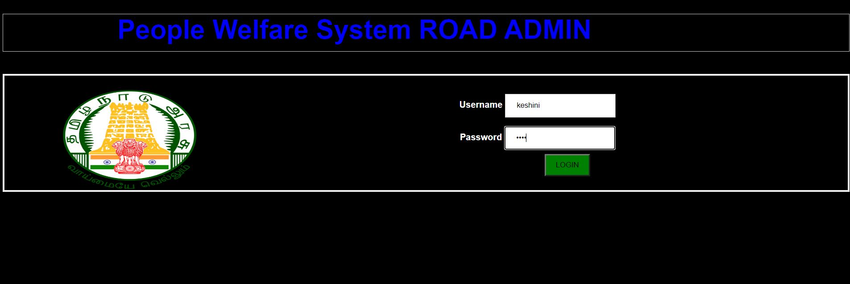

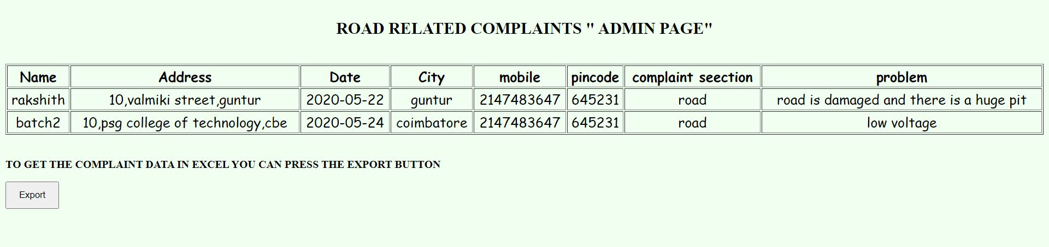

Thus the road complaint which we have registered with the **id = 4 and name=batch2** has been successfully shown under the **Road admin’s login.**

If you click on the **export button** , the complaint details will be downloaded in the form of **excel sheet** and it will be stored in local machine, such that we can maintain offline records**.**